LAB 321Assignment | Type: | LongAssignment
 | Code: | J3.L.P0013
 | LOC: | 500
 | Slot(s): | 15

Title: The Sushi restaurant

Background

Sushi is a food preparation originating in Japan, consisting of cooked vinegared rice combined with other ingredients (such as raw seafood, vegetables and sometimes tropical fruits. Ingredients and forms of sushi presentation vary widely, but the ingredient which all sushi have in common is rice (also referred to as shari (しゃり?) or sumeshi (酢飯?)).
If you want to startup with your The Sushi restaurant, try this assignment
Reference site:http://us-123sushi.simplesite.com/

Program Specifications

Program a web site tointroduce your sushi restaurant to your customer, detail functions of this website is described below

Features:
This website contains 4 main functions
- Function 1 : Home page : ( see PIC 01)
  - Display introduction entry and all menu
  - Each productcontains
    - Entry name
    - Description picture
    - Entry content
- Function 2 : Price list ( PIC 02)
  - Print out detail price of each menu
- Function 3 : Find us ( PIC 03)
  - Display restaurant address and contact inform

You do not need to write interface for admin control panel, you can add data manually (use SQL SERVER Management studio).
Note: All data must be load from database, not hard code in page.

Expectation of User interface:
Pic 01 : Home Page
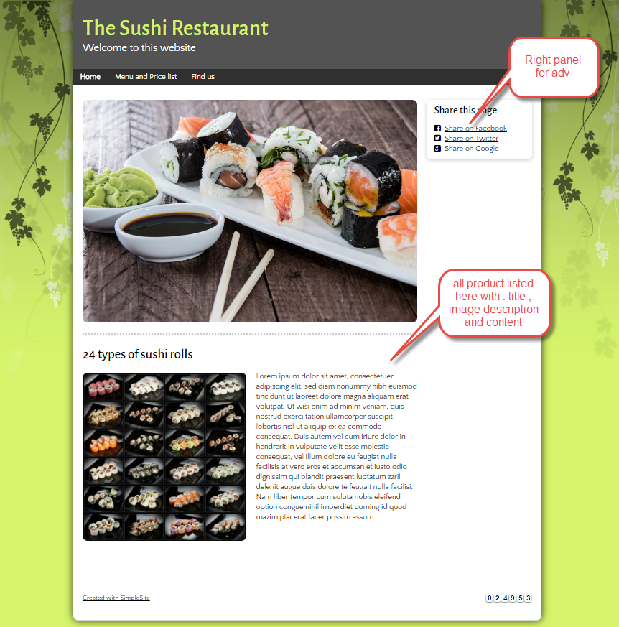
PIC 2 :Menu and price
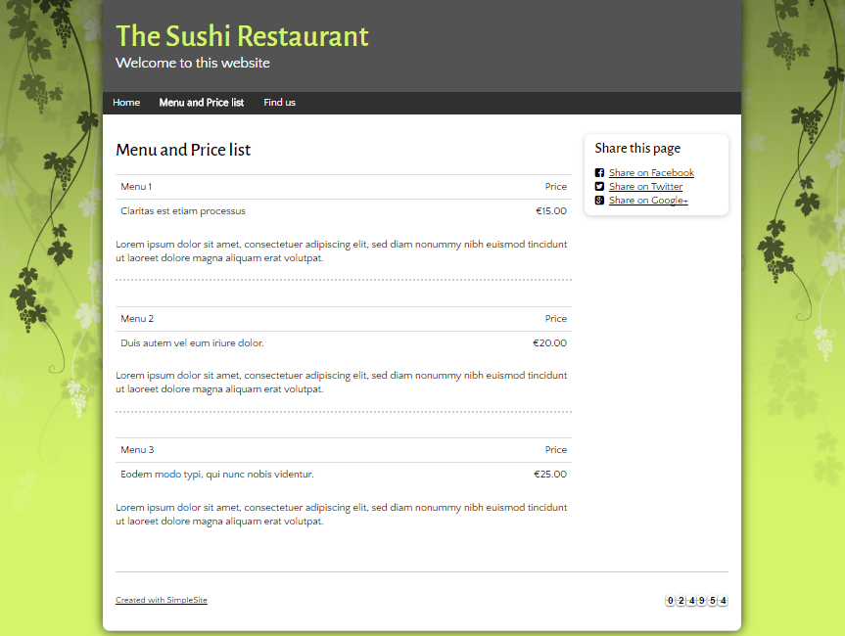

Pic 03 : Find us page
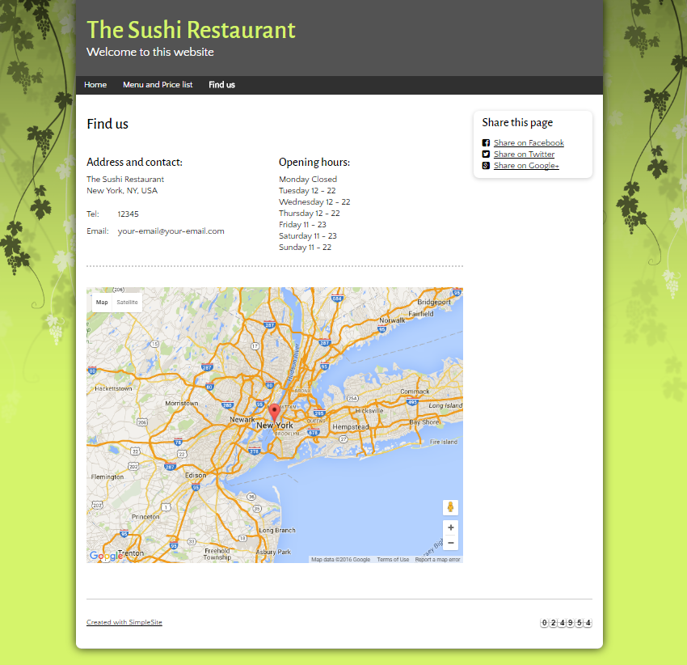

Guidelines
- Step 1 : Clarify requirement and scope with mentor
- Step 2 : Create prototype
- Step 3 : Design database base on created prototype
- Step 4 : Code & Test

